**PROGRAMMING WITH JAVASCRIPT**

**PRACTICAL**

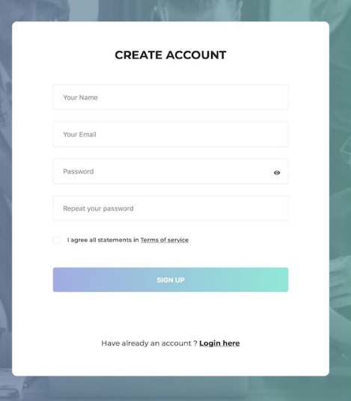

* **Validate this form:**
* Your name must contain only alphabets
* Email must contain correct syntax
* Password may have 8 character with one special character
* Repeat password should be matched from password field